***SCALING***

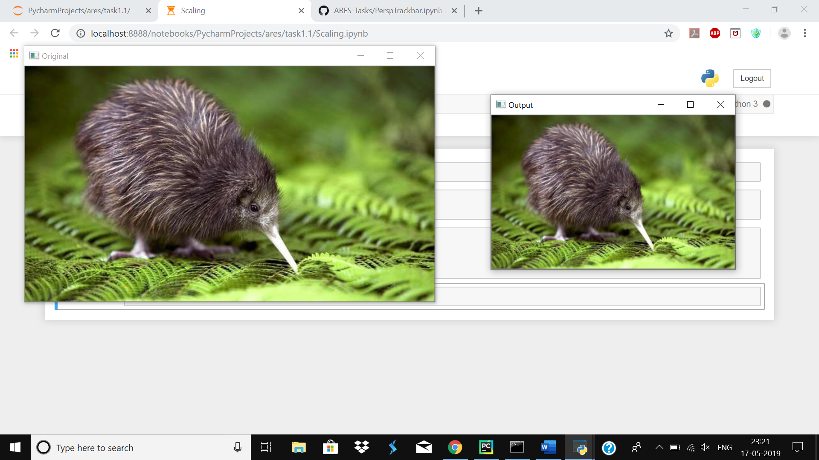

***TRANSLATION***

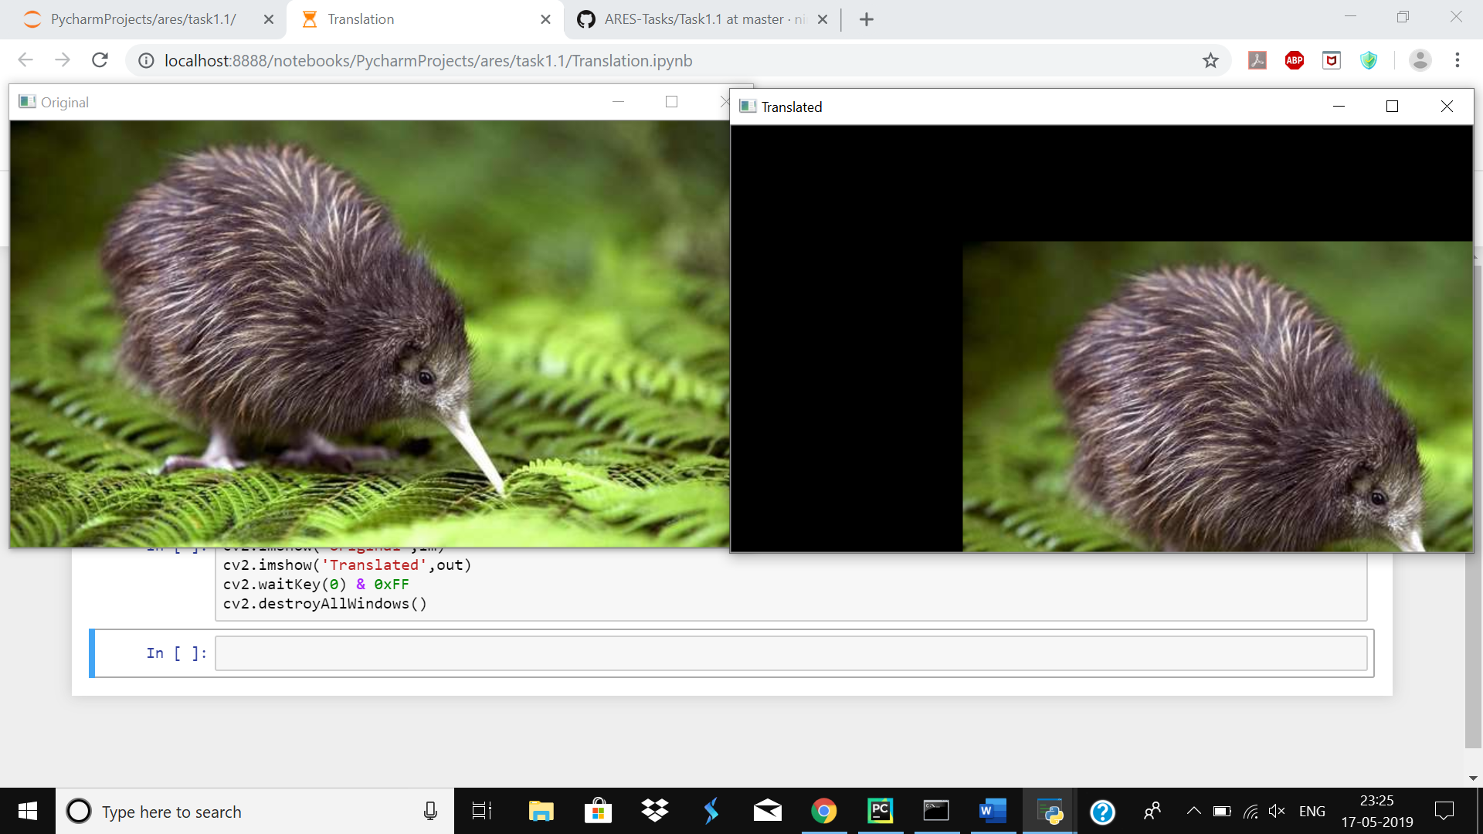

***ROTATION***

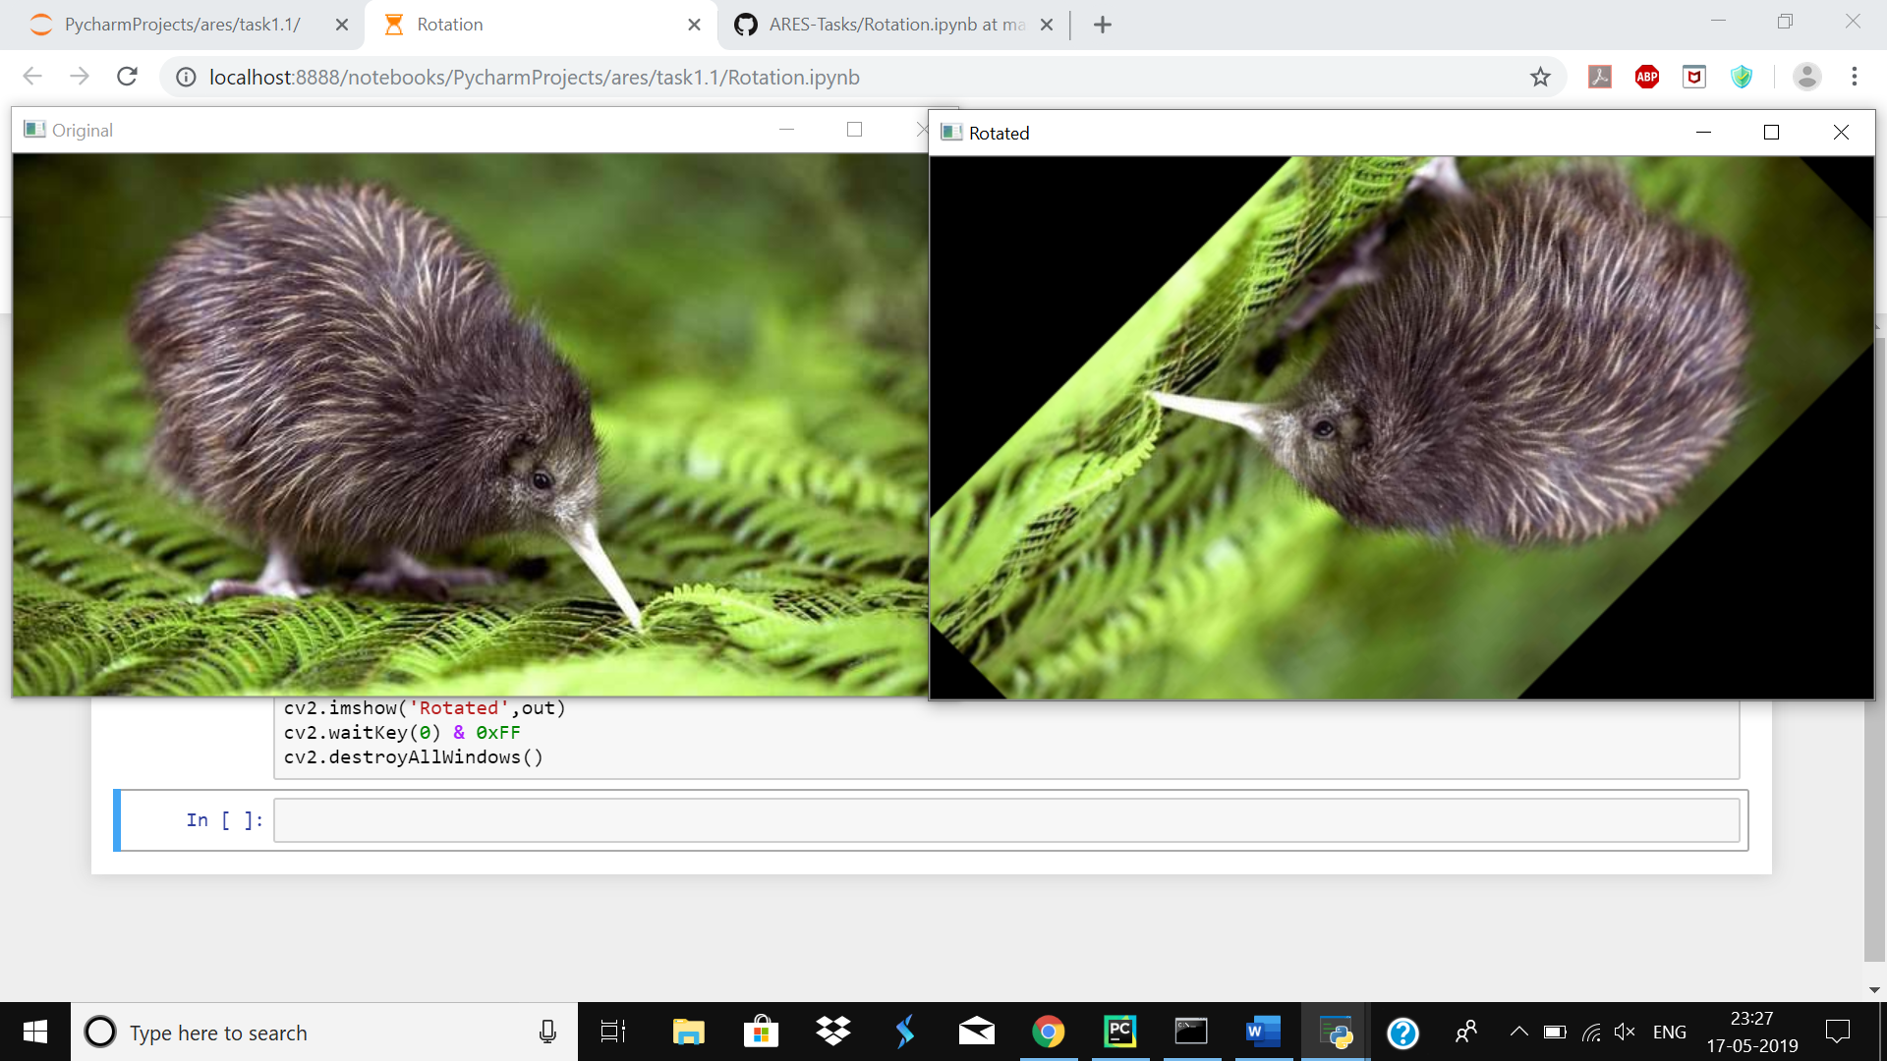

***PERSPECTIVE TRANSFORMATION***

(First points were chosen using PerspTrackbar. Then that points were passed in an array in Perspective for transformation)

